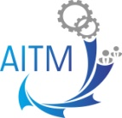
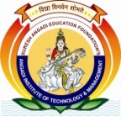
SURESH ANGADI EDUCATION FOUNDATION’S
ANGADI INSTITUTE OF TECHNOLOGY AND MANAGEMENT
Savagaon Road, Belagavi – 590 009.
(Approved by AICTE, New Delhi &Affiliated to Visvesvaraya Technological University, Belagavi)
Accredited By NBA*/ NAAC

Department of Mechanical Engineering
Association of Mechanical Engineering

Event Report

on

“Mastering in Project Selection, Report Writing and Publication Skills with AI Tools”

Event conducted on 01st October 2024

Mr.R.H.Angadi Dr. Malagouda Patil
Event Coordinator HOD, ME

Dr. Malagouda Patil Dr. Anand Deshpande
IQAC Coordinator Principal & Director

Content of the Report

- Objective of Event:
- Event Details
- Brief introduction of the event
- Audience Target (Internal or External, Students or Faculty etc.):
- Venue, Date and Time:
- Relevance to Programme Outcomes
- Geo tagged photos of event conducted for evidence:
- Conclusion

1. Objective of Event:
Department of Mechanical Engineering, Angadi Institute of Technology & Management, Belagavi Conducted “Mastering in Project Selection, Report Writing and Publication Skills with AI Tools” on 01-10-2024 in the Seminar hall at 11.00 am. The main objective is to enhance project selection by utilizing AI tools for data analysis and risk assessment, ensuring informed decision-making. Additionally, the aim is to improve report writing and publication skills through AI-driven assistance in clarity, data visualization, and efficient citation management, ultimately leading to higher-quality outputs.
2. Event Details
Event Name | “Mastering in Project Selection, Report Writing and Publication Skills with AI Tools”
Resource Person | Dr.Malagouda Patil (The Head of the Department of Mechanical Engineering)

3. Brief Introduction of the Event
Artificial intelligence (AI) tools have emerged as valuable resources in these areas, making processes more efficient and manageable. AI can assist in analyzing data for project selection, helping to identify the best opportunities based on trends and potential risks. Additionally, AI tools can improve report writing by enhancing clarity, suggesting structures, and creating visual aids to present information effectively.
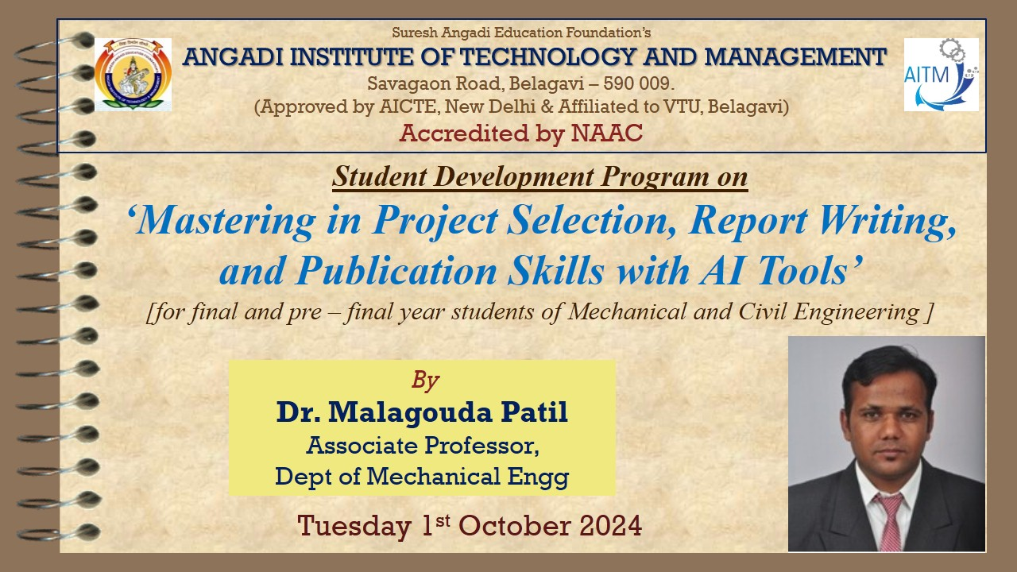
4. Audience Target (Internal or External, Students or Faculty Etc.):
The audience for the events consisted of students from Mechanical Engineering, Robotics and Automation Engineering, and Civil Engineering.

5. Venue, Date and Time:
Event was organized on Tuesday, 01st October 2024 in the Seminar Hall, at 11.00am.
6. Relevance to Programme Outcomes
PO1: Engineering Knowledge
PO5: Modern tool Usage
PO8: Ethics
PO9: Individual and team work
PO10: Communication
PO11: Project management and finance
PO12: Life-long learning

7. Geotagged Photos of Event Conducted for Evidence:

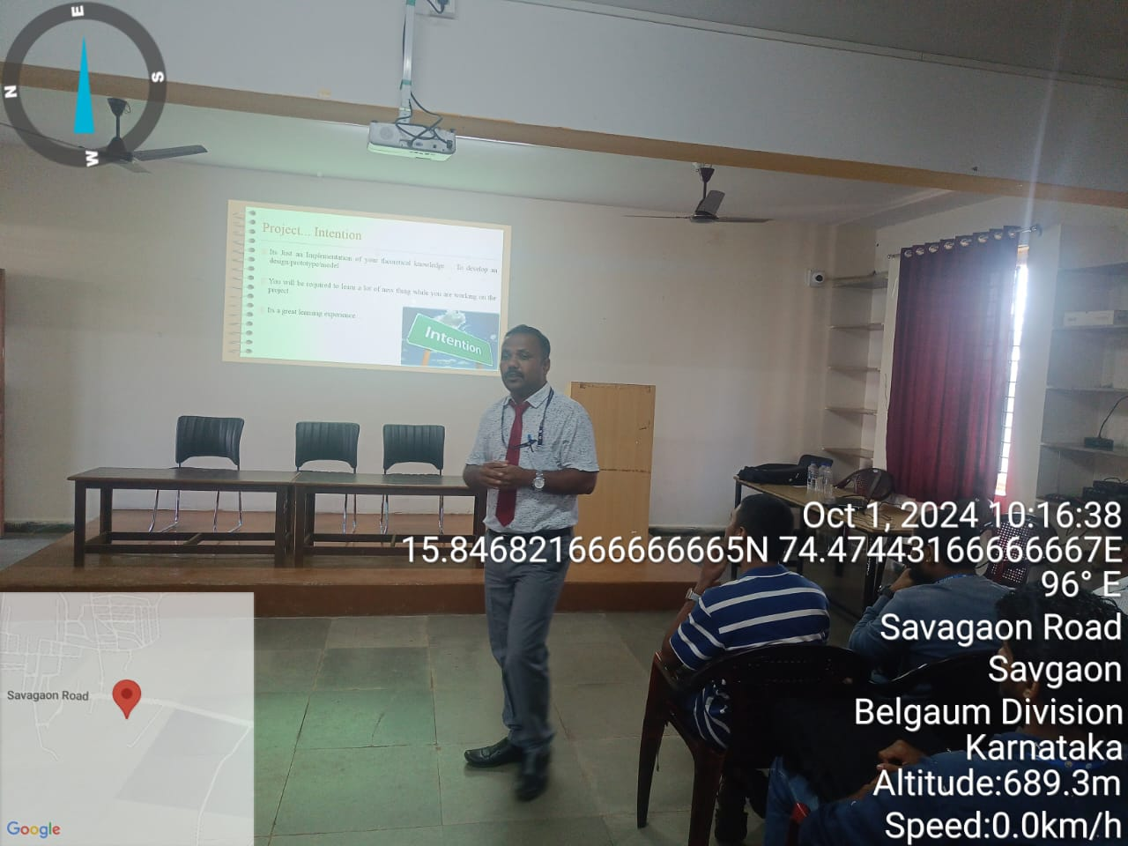 | 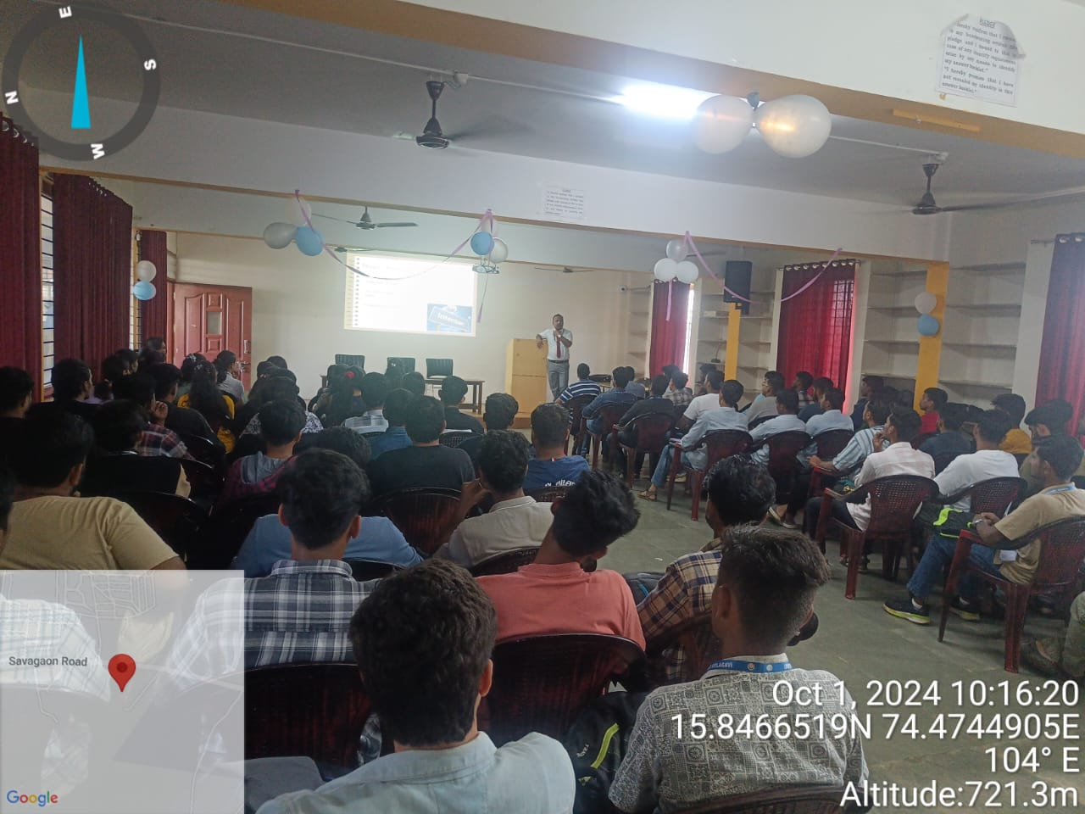
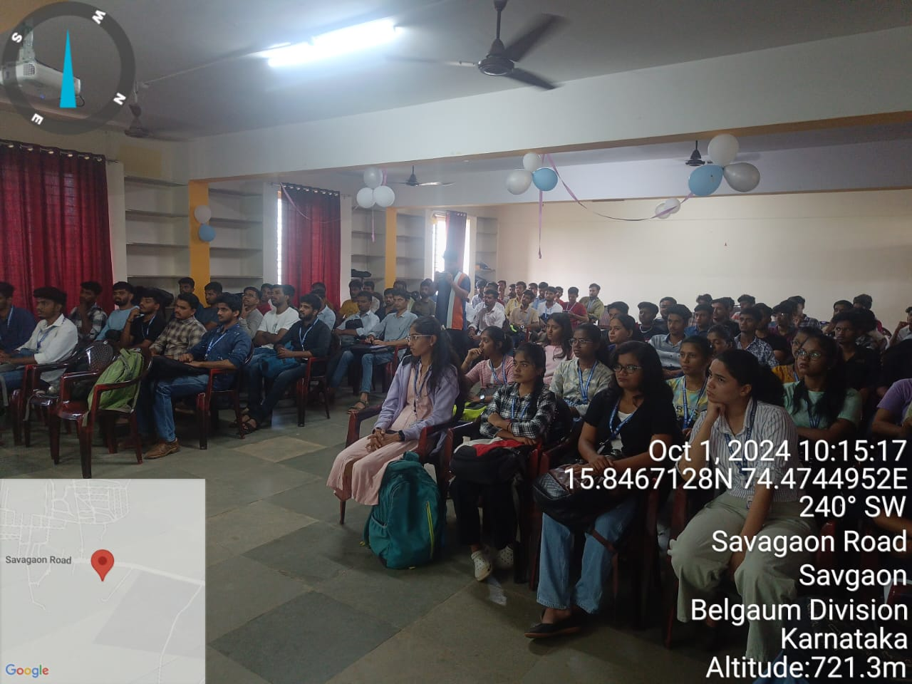 | 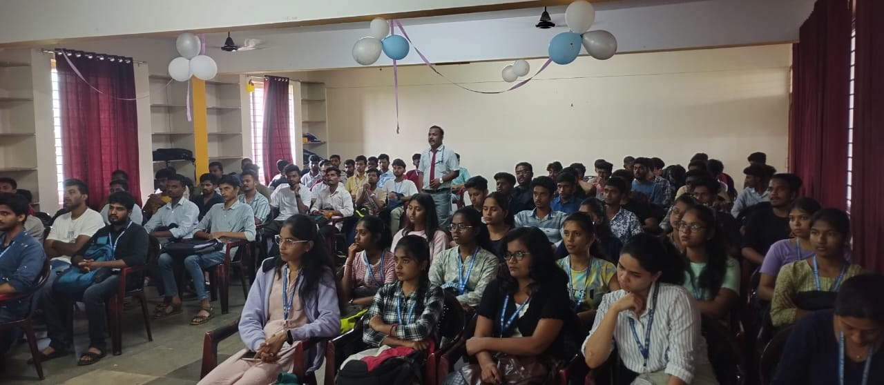

8. Conclusion
Mastering project selection, report writing, and publication skills using AI tools empowers the UG Students to boost both efficiency and quality. AI aids in selecting relevant topics through data analysis, ensuring timely and impactful projects. For report writing, AI enhances clarity, structure, and precision while automating tasks like formatting and citations. In publication, AI tools help identify suitable journals, refine language, and detect errors. By leveraging these technologies, researchers streamline processes, increase productivity, and elevate their work to meet high academic standards, ultimately enhancing their contributions to their fields.

